**INDIA'S AGRICULTURE CROP PRODUCTION ANALYSIS (1997-2021)**

**1 INTRODUCTION**

**1.1 OVERVIEW**

**India's Agricultural Crop Production Analysis(1997-221) This report delves into the captivating realm of india's agricultural cultivation,providing a comprehensive visual exploration of key aspects and trends in the agricultural sector.Through the visual representations,readers can gain valuable insights into crop production,seasonal variations,regional distribution,and overall production trends.These visualizations enable intuitive analysis,allowing stakeholders to uncover patterns,identify areas of growth or concern,and make data-driven decisions.**

**1.2 PURPOSE**

**Harnessing the power of Tableau,this report not only presents the data in a visually appealing manner but also provides an interactive experience for readers to explore the intricacies of India's agricultural cultivation. To extract the insights from the data and put the data in the form of visualizations, Dashboards and Story we employed Tableau tool.**

**2 PROBLEM DEFINITION & DESIGN THINKING**

**2.1 EMPATHY MAP**

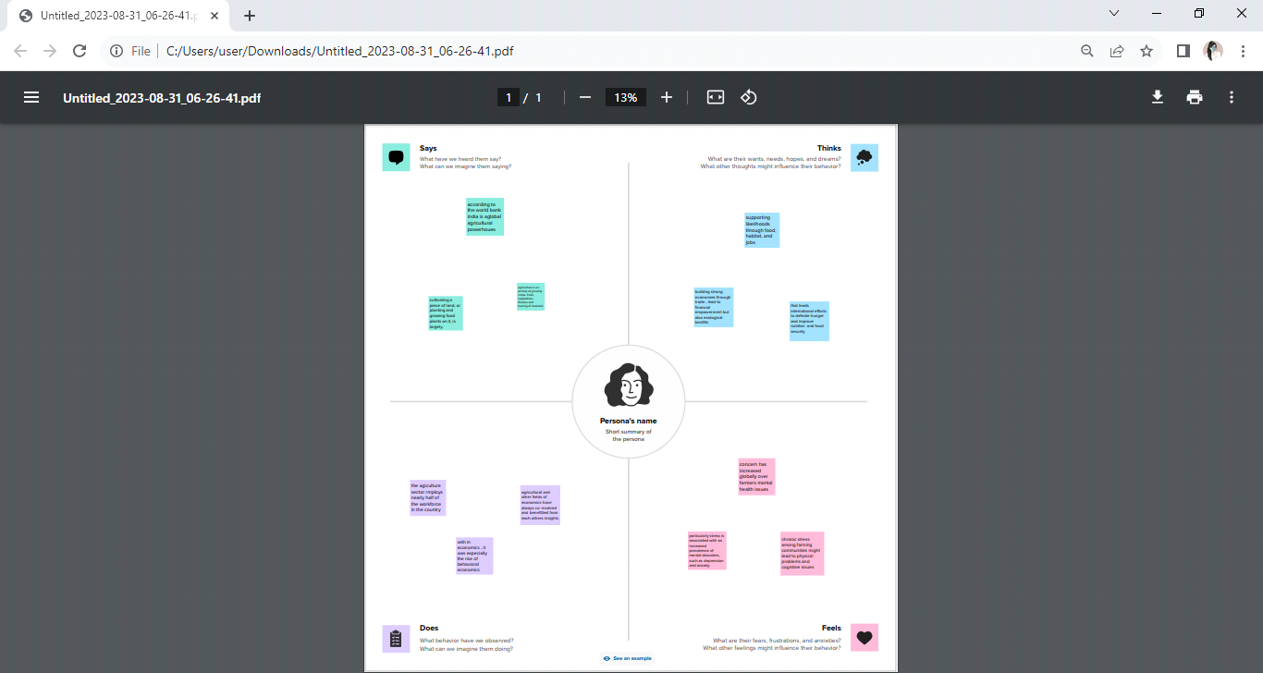

**2.2 IDEATION & BRAINSTORMING MAP**

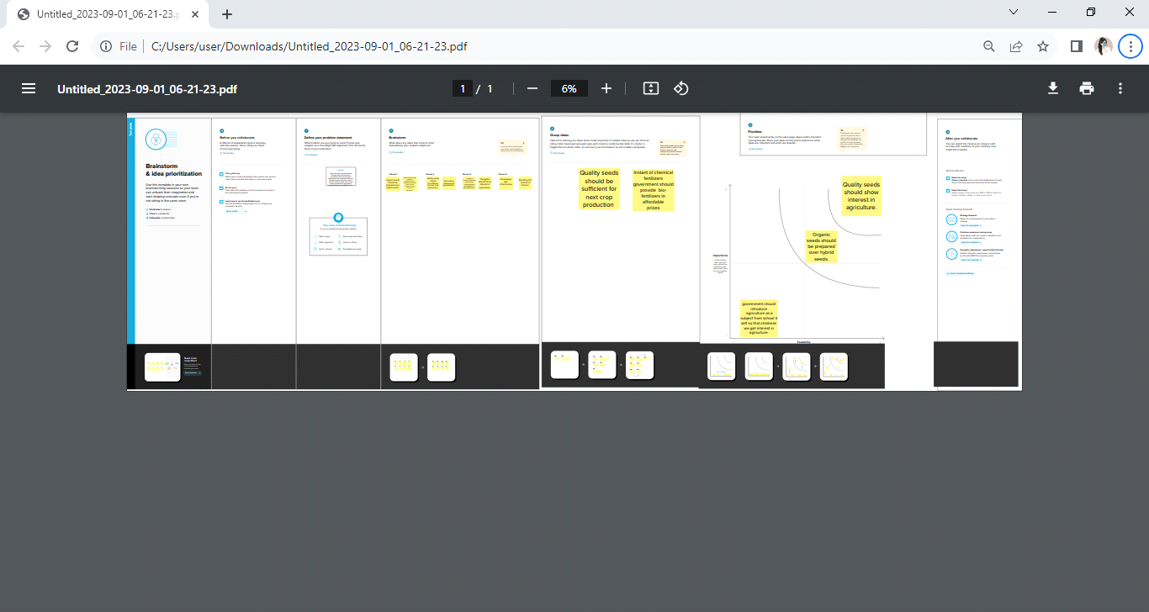

**3 RESULT**

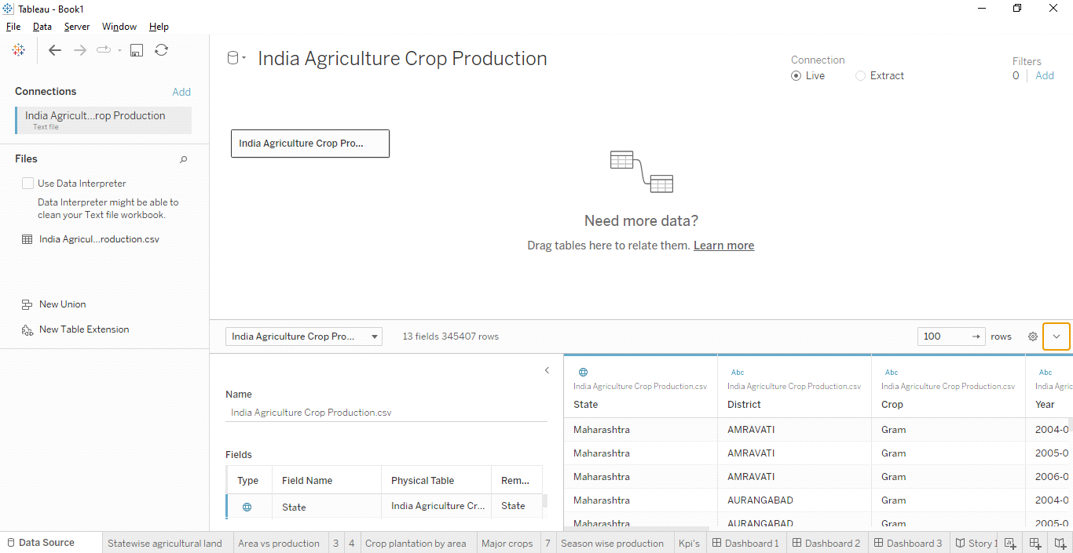

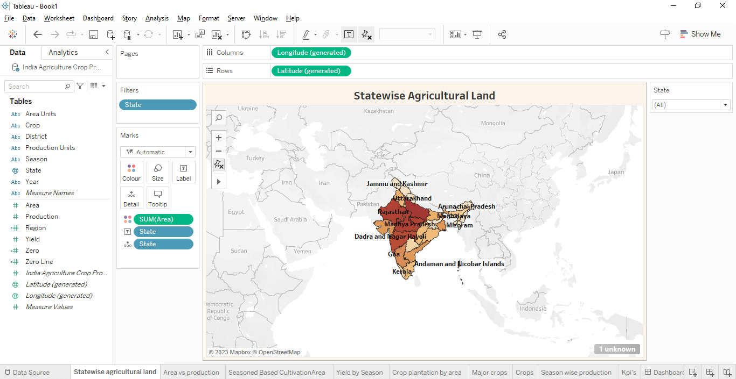

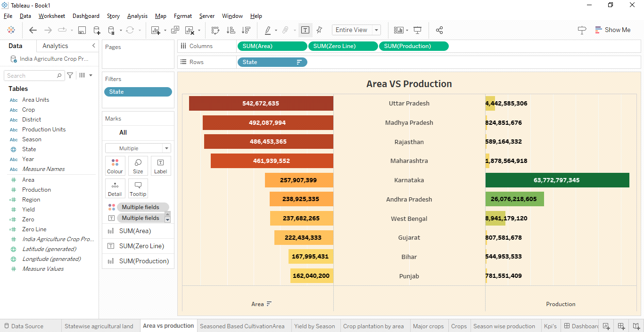

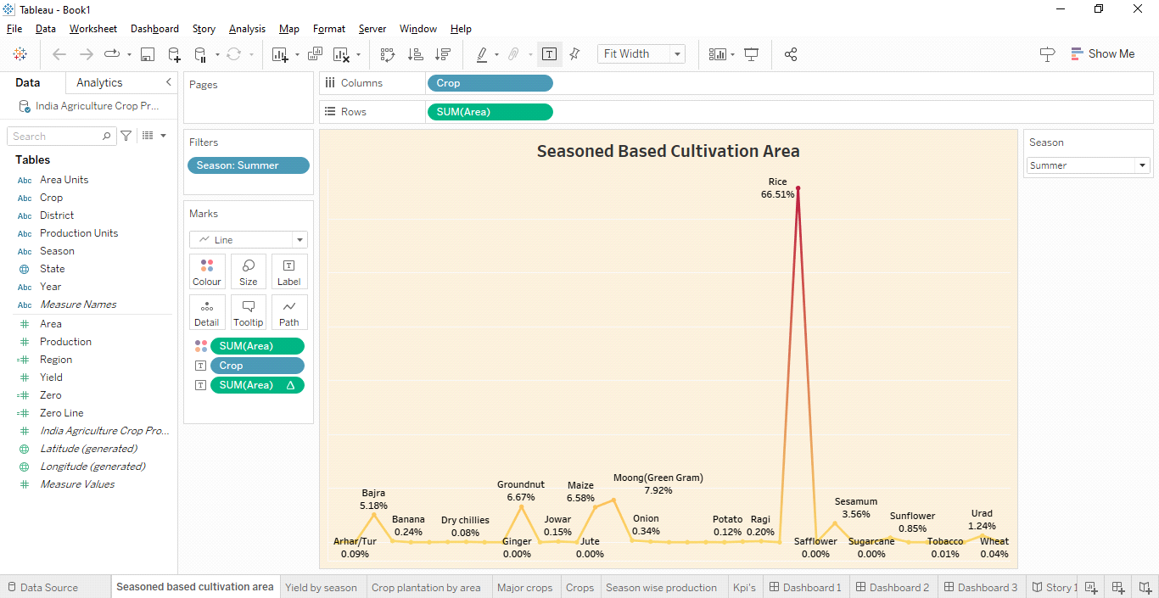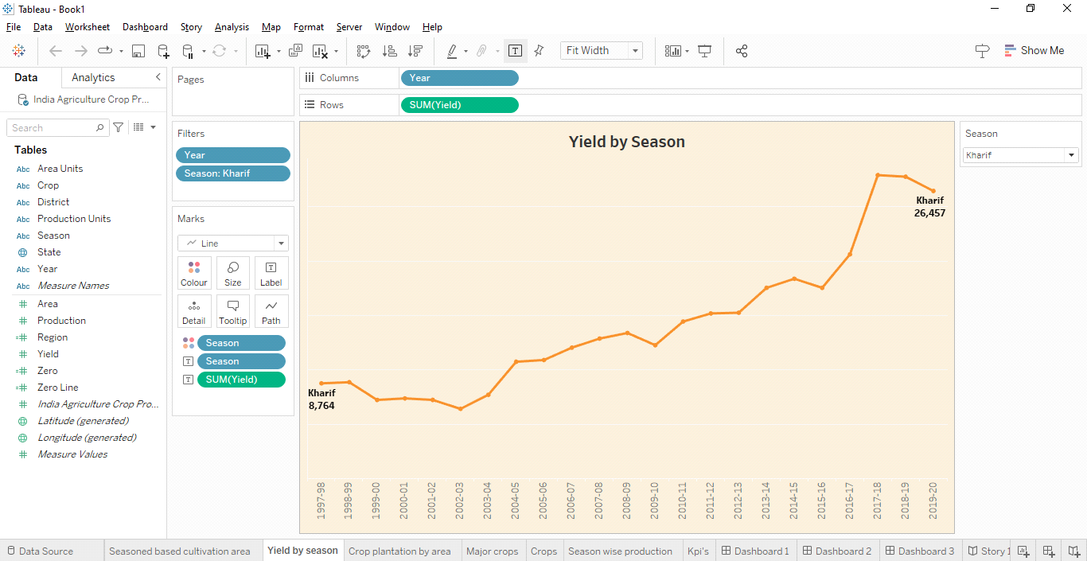

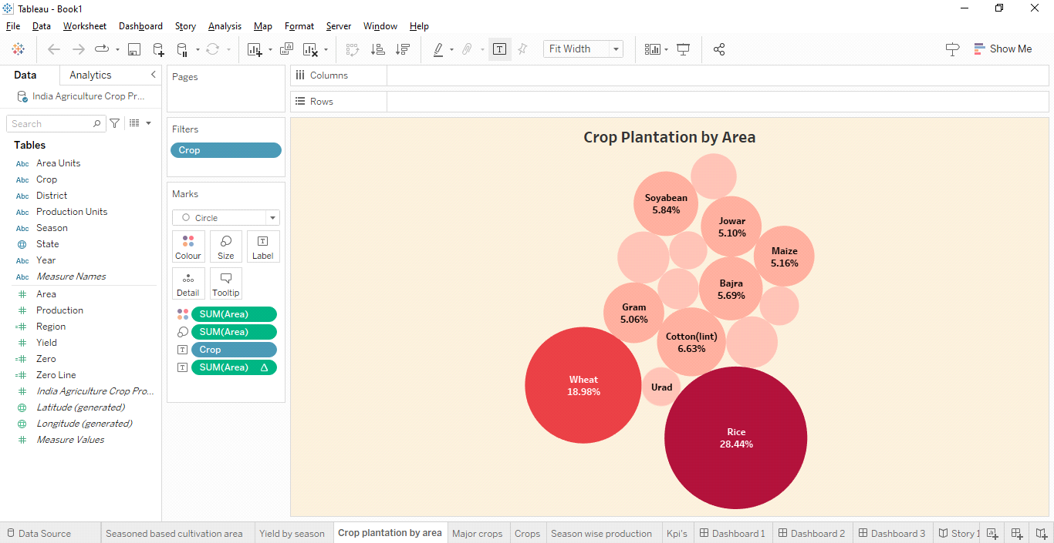

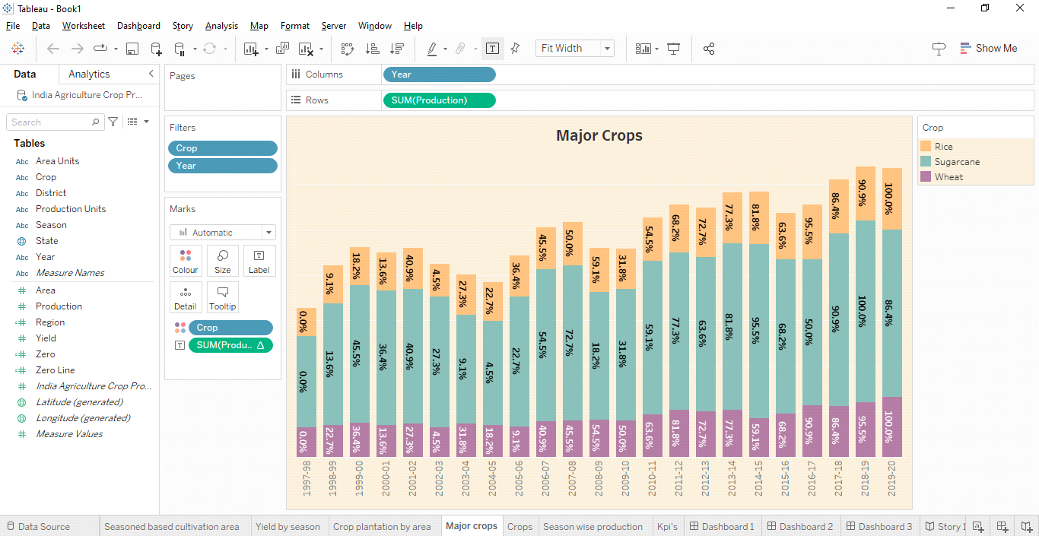

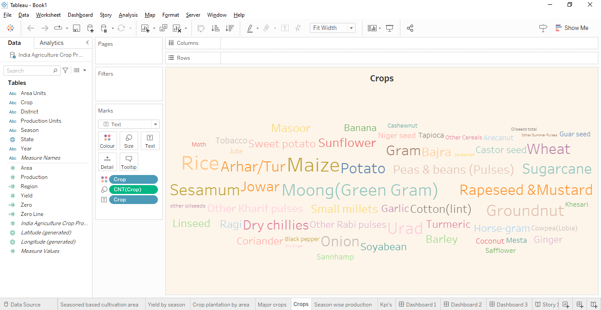

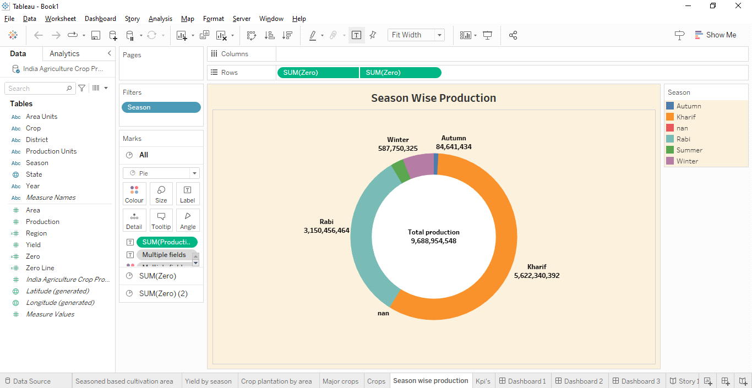

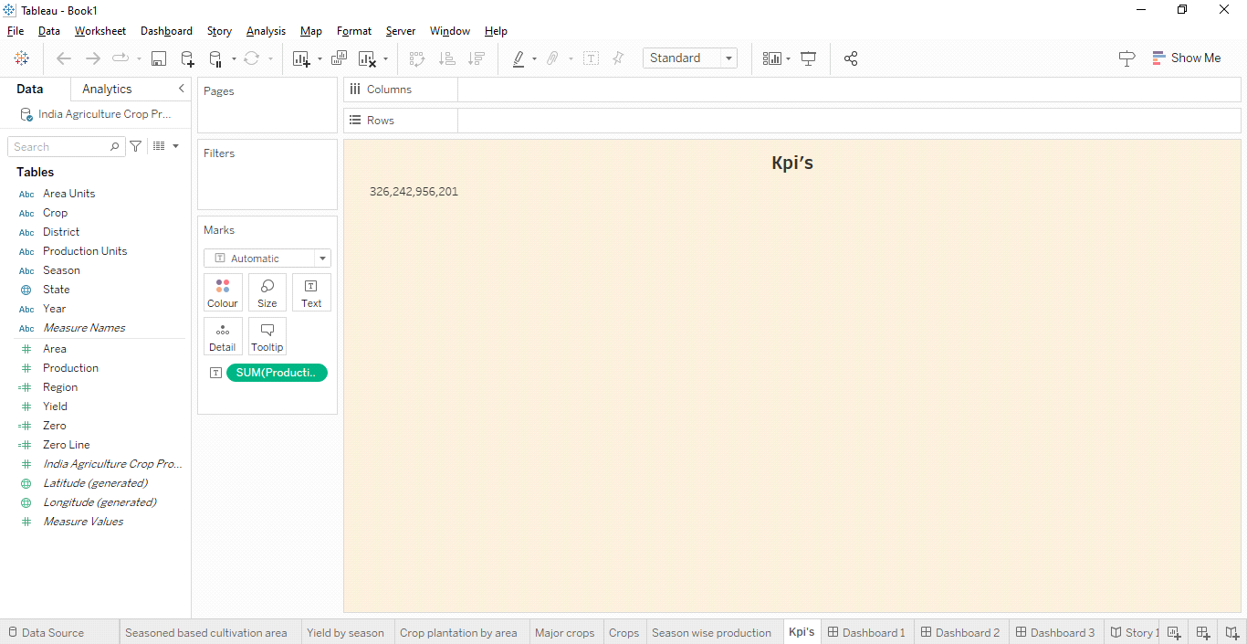

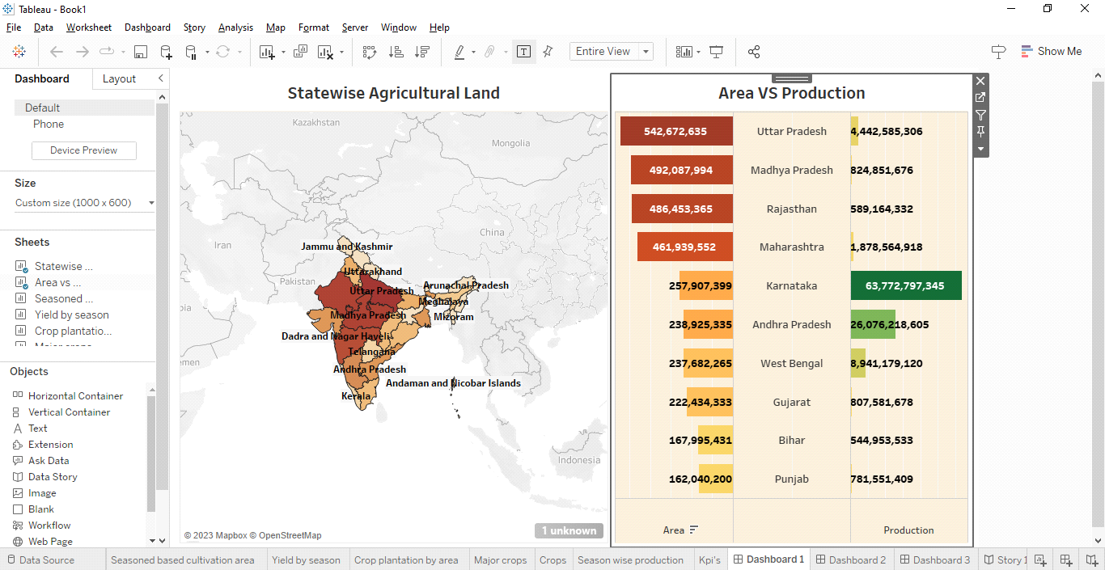

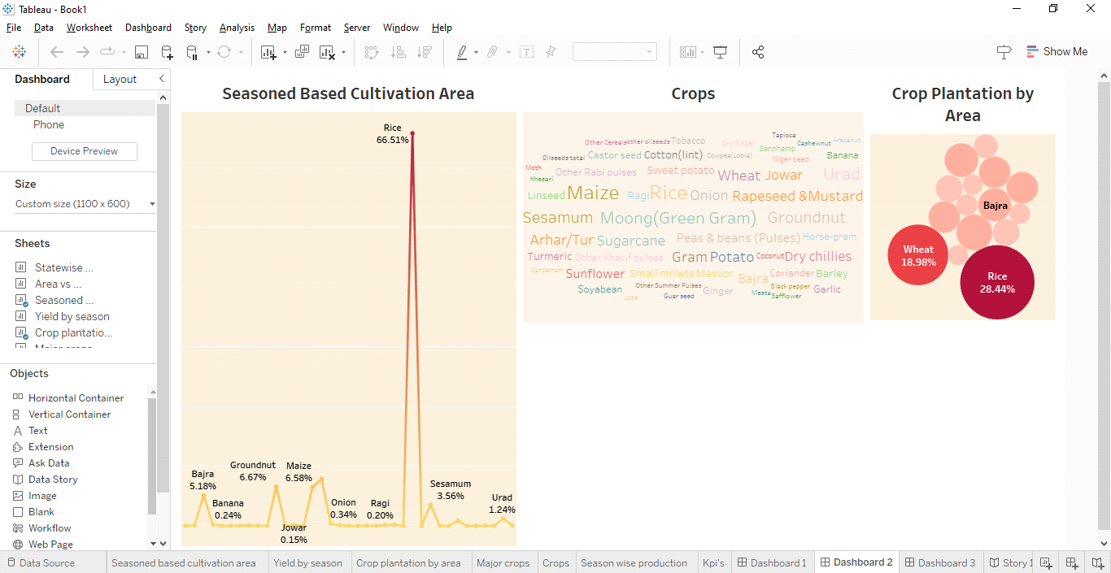

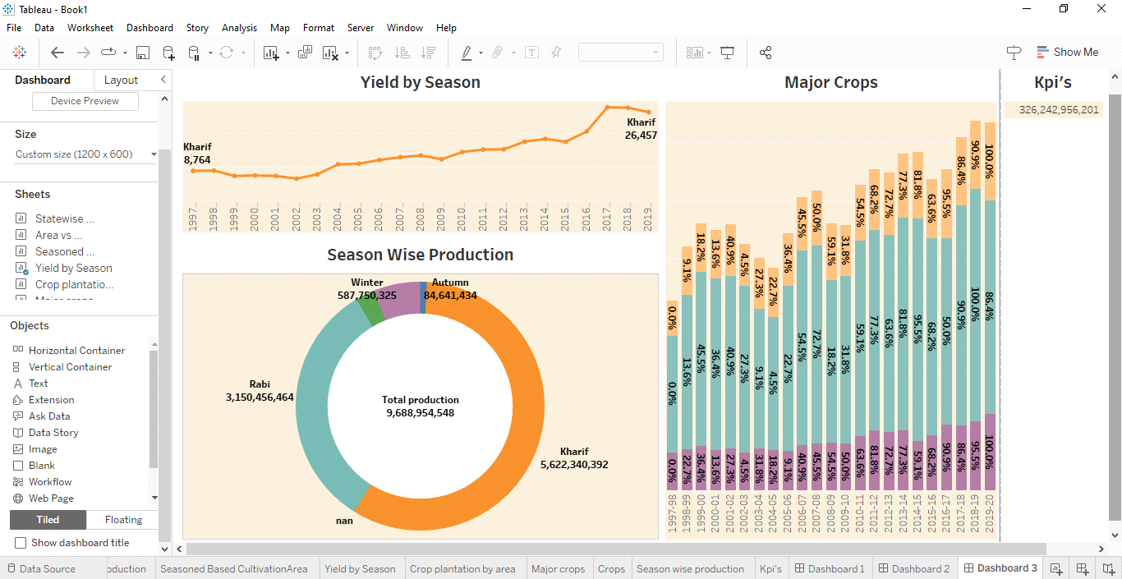

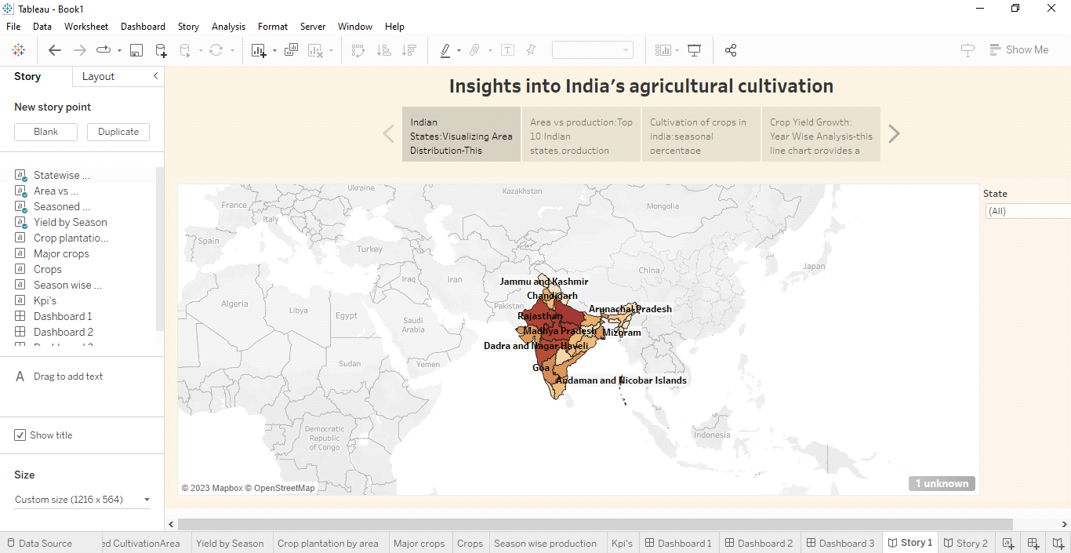

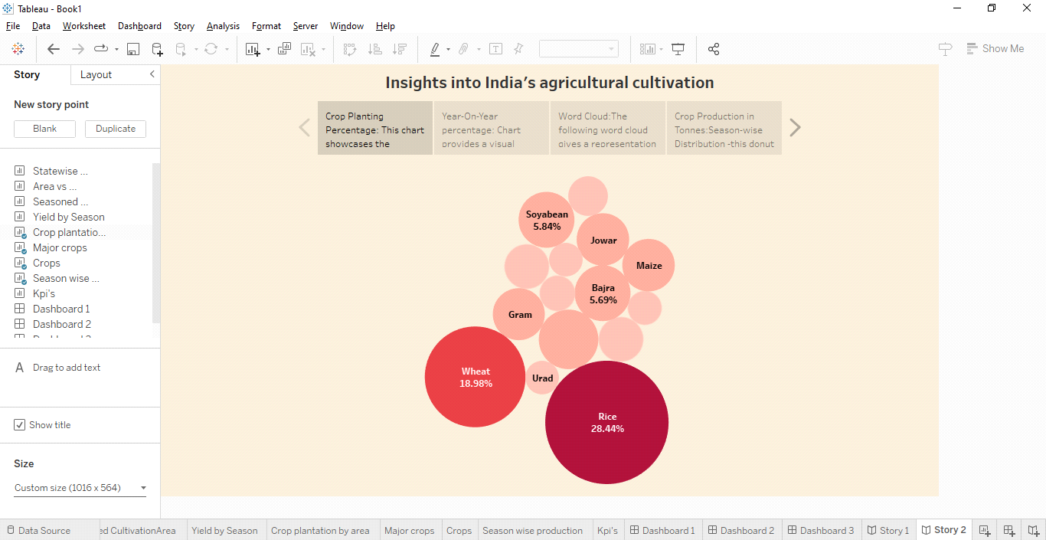

**4 ADVANTAGES & DISADVANTAGES**

**ADVANTAGES**

**This project help's us to analyze the Indian crop production from (1997-2021)**

**Encouraging crop diversification can reduce dependency on a few staple crops and enhance nutritional diversity.**

**Proper water resource management can improve irrigation efficiency,reducing water wastage and ensuring sustainable agriculture.**

**DISADVANTAGES**

**One of the disadvantages is that the we cannot at analyze other years other than (1997-2021)**

**While some farmers may benefit from modernization,smaller and marginalized farmers might struggle to keep up,exacerbating income inequality.**

**Inheritance and land division can lead to smaller landholdings,making it challenging to adopt modern equipment and practices.**

**5 APPLICATIONS**

**This solution can be applied in various areas within India's agricultural sector,including:**

**1. Crop Monitoring:**

**Implementing remote sensing and Al technologies for crop monitoring to assess crop health, detect diseases,and predict yields.**

**2. Precision Agriculture:**

**Utilizing data-driven insights to optimize the use of resources like water,fertilizers,and pesticides for more efficient and sustainable farming.**

**3. Weather Forecasting:**

**Integrating weather data and predictive analytics to provide farmers with accurate weather forecasts, helping them plan their planting and harvesting activities effectively.**

**6 CONCLUSION**

**India's agriculture crop production analysis from 1997 to 2021 reveals a complex and dynamic landscape. over this period, the country has witnessed notable fluctuations influenced by factors such as climate conditions,technological advancements,and policy changes. Deapite facing challenges like unpredictable weather patterns and water scarcity, India has demonstrated resillience and adaptability in its agricultural practices. the adoption of modern agricultural techniques,improved seeds,and irrigation methods has contributed to overall growth.However,regional disparities persist, highlighting the need for targeted interventions to ensure sustainable development across the agricultural sector. in conclusion, India's agriculture has shown both progress and challenges over the past two decades, emphasizing the importance of comprehensive and adaptive strategies for the future.**

**7 FUTURE SCOPE**

**The future scope for India's agriculture and crop production analysis,building on the trends observed from 1997-2021, encompasses several key areas:**

**1. Technology Integration:**

**Embracing advanced technologies such as precision farming, artificial intelligence, and remote sensing can enhance productivity and resource efficiency. Precision agriculture, in particular,can optimize inputs, reduce waste, and improve yields.**

**2. Climate-Resilient Practices:**

**The increasing impact of climate change, the adoption of climate-resilient crops and sustainable farming practices will be crucial. investing in research and development for crops that can withstand extreme weather conditions is imperative.**

**3. International Collaboration:**

**Collaborating with international organizations and sharing best practices can provide India agriculture with global perspectives and solutions to common challenges.ś**